__________________________________________________________________________________________
Analysing the Impact of Online Gambling Platforms on the Socio-Economic and Psychological Well-Being of Young Adults
Nilkamal School of Mathematics, Applied Statistics & Analytics – NMIMS (Mumbai)
Sameer Bhavnani¹ , Khushi Sahni¹ , Dr. Rushina Singhi¹
___________________________________________________________________________

ABSTRACT:
In this study, we analyze the myriad of effects that web based gambling stages have on the socioeconomic and mental prosperity of young grown-ups. Online gambling has become ubiquitous since it is available to everyone, with the rapid digitalization of gambling through Dream11, Bet365 and even Stake, young people are attracted heavily into gambling. We analyze the behavior patterns, financial strain and mental health outcomes resultant of online gambling based on the primary survey data obtained from the 252 respondents between the age of 18 and 26 years w.r.t to online gambling. In order to segment respondents into four unique profiles of actors, a cluster analysis was carried out on respondents to identify four distinct profiles: High Risk Gamblers, Occasional Gamblers, Older Controlled Gamblers, Financially Affected Gamblers. These clusters had very different gambling frequency, urge intensity, emotional distress, financial loss, and lifestyle disruption. Specifically, groups within the High Risk and Financially Affected categories experienced socio-economic consequences as marginal loss of savings, selling of belongings, disruptions to work or study, and higher anxiety and guilt. However, Occasional and Controlled Gamblers showed little negative outcomes. What the findings make clear is that online gambling is an issue that requires increasing awareness of, support for, regulation of and investment in mental health. Importantly, this research provides useful insights into behavioural addiction, youth issue, and digital financial risk convergence in contemporary society.

KEYWORDS: Online Gambling, Impact, Cluster Sampling, Young Adults, Chi- Square, ANOVA

1. INTRODUCTION:
An increase of the online gambling industry has created a completely different approach to the gaming and betting feed due to its availability and usefulness. (Antonio et al., 2025). It has attracted tech savvy young men and women, because of the range of options and time saving qualities offered through digital platforms (Potenza et al., 2025). Yet such transformation has also sparked increasingly concerns over its negative socio-economic and psychiatric impact, specifically upon young adults (Fahrudin et al., 2024). However, due to the wide penetration of internet and smartphones in India, the popularity of online gambling has seen an unprecedented surge in the country.
Large numbers of young Indians have been drawn by the promise of quick money and entertainment value (Indra et al., n.d.; Kartawinata et al., 2025). But of course this trend has followed its appeal a lot with its negative consequences including, financial insecurity, mental health disorders, social challenges (Vijayakumar & Vijayakumar, 2023). The thing of immediate concern is addiction potential. Accessibility to online gambling sites can be through easy access through which someone can get hooked on and hence end up losing a lot of money, creating debts and more than bankruptcy (Potenza et al., 2025). Such financial strain is damaging to one’s mind and can lead to development of anxiety, depression and other psychiatric disorders (Fahrudin et al., 2024).
Furthermore, problems regarding relationships, isolation, and relationship breakdowns often accompany the problem of gambling addiction, intensifying the harm (Potenza et al., 2025). The determinants of gambling behaviour among young Indian adults are many, both socio and economic, and they include peer pressure, social norms and ways of gambling prevalent among the young Indian adults (Antonio et al., 2025). Since gambling is often glamorized on social media and on online forums, such as success stories and promotions, the gambling would be heightened (Indra et al., n.d.).
The main problem is the psychological stress of the online gambling. The addictiveness of these platforms as mentioned earlier embraces instant gratification, which entails the eagerness to find pleasure quickly and also its interactional nature is what leads to mental health issues (Potenza et al., 2025). Therefore, the effectiveness of existing regulations and support systems is crucial for current regulations, and for enforcement specifically, due to the hot pace of technological evolution and owing to the cross-border nature of online gambling (Nur et al., n.d.).
The psychological consequences associated with gambling in young adults are many, not all of which are psychological. Usually the result of an skewed perception of reward and risk gambling becomes a solvable means of making money (Antonio et al., 2025). It’s a false sense of control that can lead to taking studies, jobs and other responsibilities for granted in the attempt to acquire instant wealth (Fahrudin et al., 2024).
Also, the broad availability of gambling platforms has made gambling common to all socio economic classes and has worsened disparities and engaged in its exploitation (Kartawinata et al., 2025). Because of the difficulty of effective enforcement, the internet gambling regulatory landscape continues to evolve with great volatility (Nur et al., n.d.).
Ultimately, the rise of online gambling holds serious implications for the socio-economic and psychological welfare of young adults. This is why it is important to understand these dimensions in order to design effective interventions in order to mitigate the potential harm (Indra et al., n.d.). Popularization of online gambling and the digital revolution have turned young adults mainstream. This has resulted due to their openness to one thing, to innovate. (Potenza et al., 2025). However, growing popularity of the streamer requires more detailed monitoring of implications for the socio-economic and psychological aspect. Gambling behaviours are highly influenced not only by one’s own personal opinions but also by informal and informal socialization through socialization and trends (Vijayakumar & Vijayakumar, 2023).
It can create FOMO (fear of missing out) which then makes one participate to be socially relevant. Online gambling’s interactive platforms and possibility for instant gratification can psychologically distort one’s perception of reward and risk and lead a person to quit studying, working and other tasks in search of instant wealth (Antonio et al., 2025; Fahrudin et al., 2024). The gamification features of virtual rewards and leader boards make it hard to divide the fun and gambling lines, reinforcements of addictive behavior (Potenza et al., 2025). Without such understanding, it is important to create targeted interventions to protect potential harms (Indra et al., n.d.).

2. LITERATURE REVIEW:
Online gambling, which includes Stake, has also made a difference in many, specifically young adults-Gen-Z and millennials. Gambling habits are influenced by the social and economic factors such as income levels and accessibility; younger individuals have a higher susceptibility to habitual gambling (Antonio et al., 2025). For students and low income groups, they are especially experienced in terms of psychological effects such as addiction and lowered self-control. The nature of gambling habits is also conditioned by financial availability and lack of parental monitoring, especially with adolescents in the case (Lombardi et al., 2024). Online gambling is accessible and addictive and presents psychological risks particularly with slot machines and betting associated with problem behaviour. Because adolescents are particularly autonomous, have formed an identity, and are highly sensation seeking and impulsive, they are especially vulnerable (Potenza et al., 2025). All are susceptible, and although they wouldn’t necessarily suffer more severe problems than others, anonymity and accessibility make their millionaire gambling online easier than it is for those not at risk, and easier than ever (Bush-Evans et al., 2024).
The findings emphasize the importance of targeted interventions and tighter regulating online gambling in combating dubious socio-economic and psychological side of it (Dowling et al., 2025). The link between risky loot box purchases and problem gambling and increased depression, anxiety and impulsivity in young adults is very strong. Such issues show the necessity of assessing the efficacy of the regulatory measures aimed at limiting harm (Villalba-García et al., 2025). Thus, financial institutions have a critical role to curb gambling related harms such that impulsive spending and financial distress can be associated to overall socio-economic and psychological well-being. Financial stress associated with problem gambling, especially through scratch cards and poker machines, is significantly greater than expected, and females experience more financial stress despite higher gambling severity on the part of males (Koomson et al., 2022). Improving financial literacy and inclusion may have the potential to contribute to the reduction of the negative effects of gambling on a person’s socio-economic position as a means of improving financial resilience (Lakew et al., 2024).

3. OBJECTIVES:
- To investigate the prevalence of online gambling among young adults
- To examine the socio-economic factors influencing online gambling behavior.
- To assess the psychological impact of online gambling on young adults.
- To explore the awareness and effectiveness of existing regulations and support services.

4. METHODOLOGY:
4.1. Conceptual Framework and Research Model
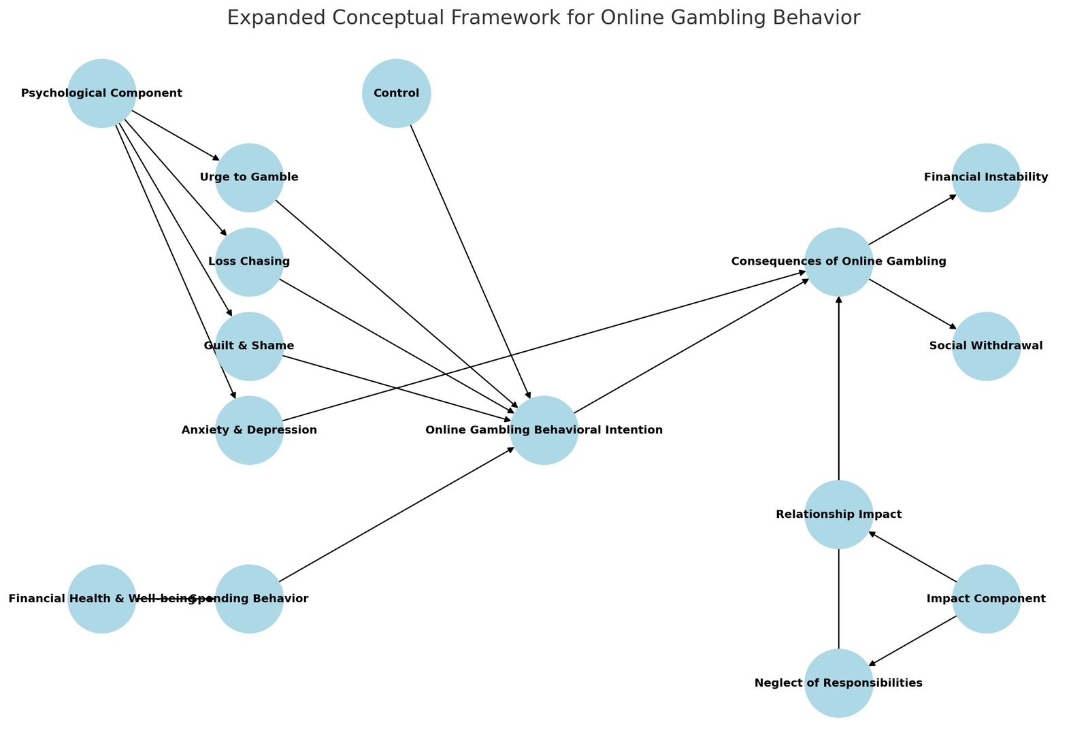
Fig 1: Conceptual Framework

4.2. Clustering Analysis of Online Gambling Behavior
Based on the above objectives we did a clustering analysis to segment people based on the gambling behaviours. This approach helped us in discovering different groups who engage in similar gambling pattern that can be used in developing targeted intervention and policy recommendations.
To understand the socio-economic and psychological impacts of online gambling on young adults, we employed a clustering analysis to segment individuals based on their gambling behaviours. This approach allowed us to identify distinct groups with similar gambling patterns, which can inform us about targeted interventions and policy recommendations.
4.2.1 Data Preprocessing
Accurate and reliable clustering was the main key of the data preprocessing phase. The non informative columns e.g. names were removed and aimed to concentrate into variables related to gambling behaviours such as gambling frequency, gambling spending, and gambling’s psychological impact. Finally, categorical variables, in this case gender and occupation, were encoded with the help of Label encoding to convert them to numerical values for the clustering algorithms to understand the data. The data was finally standardized using StandardScaler to standardize the scales of different variables (i.e. money spent vs. gambling frequency), so that each variable have the same influence in the clustering process. In order to prevent variables with larger scales from exerting a disproportionate effect on the results, we standardized this step in order to maintain the integrity of the clustering analysis.
4.2.2 Choosing the Optimal Number of Clusters
Two methods of choosing the optimal number of clusters (K) were used to find.
Elbow Method: This method looks at which sum of squared distance (the inertia) within clusters, when more clusters are added, does not significantly decrease the clustering. The value of the 'elbow' marks the optimum number of clusters.
Silhouette Score: This metric measures how well separated the clusters are, the higher the score, the better the clusters are defined. With multiple values tested (K=2, 3, 4, 5), we chose K=4 since it divided the data into good segments.
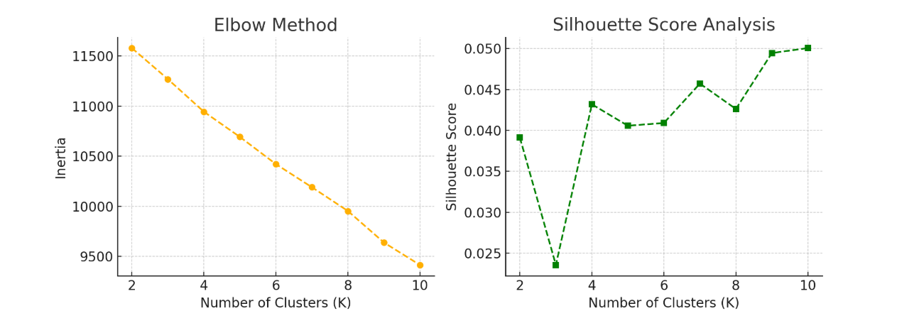
Fig 2: Clustering Methods

4.2.3 Applying K-Means Clustering
For the purpose of dividing individuals into four groups, we used K-Means with K = 4. Initialization is K cluster centroids random selected by K-Means algorithm. In the assignment phase, each point is assigned the closest centroid by using the Euclidean distance. After all the points are mapped, the update phase then finds the centroids by finding the mean position of all the points in each group. The assignment and update phases are repeated many times and the stabilize happens when the centroids don’t change much. This makes the later clusters well separated and well defined, which is highly segregated individuals by their attribute.
4.2.4 Justification for Using K-Means
There were many reasons why we picked K-Means clustering algorithm for this. Since it is computationally efficient, it is suitable for large datasets. It can be used for continuous and ordinal data after preprocessing. Thus, by contributing to scalability of the data. Furthermore, the algorithm uncovers the behavioural segments in a way that is meaningful to understand gambling habits and how they impact individuals.

5. Cluster Validation and Profiling
To validate our clusters, we performed a detailed analysis by comparing the mean values of key variables across clusters and conducting statistical tests to confirm significant differences. The profiling of clusters is based on the characteristics of individuals segmented through the K-Means algorithm with K=4.
The four clusters identified are High-Risk Gamblers (Cluster 1), Occasional Gamblers (Cluster 2), Older Controlled Gamblers (Cluster 3), and Financially Affected Gamblers (Cluster 4).

5.1. ANOVA Test for Numerical Variables
One way Analysis of Variance (ANOVA) was used to test statistical significance of difference in numerical variables across clusters between age, gambling frequency and gambling session duration. The age group was tested at p < 0.05 using the F-statistic with the critical F value of 2.70 and values greater than this were deemed statistically significant; hence, the value of 69.65 for the F-statistic is significantly greater than the critical value. In the case of gambling frequency and session duration, the F-statistics were found to be greater than the critical value, hence it is also confirmed that these parameters vary significantly among clusters. The segmentation is thus validated because the groups differ in regards to their gambling behaviour.

5.2. Chi-Square Test for Categorical Variables
A Chi-Square test of differences in negative impacts on work and studies was carried out across clusters. An expected frequencies was calculated for all categories in a contingency table as a result. The computed Chi-square statistic (128.6) is significantly higher than the critical value of 12.59 at df = 6, p < 0.05. This confirms that the negative effect is very heterogeneous to clusters. In particular, Gamblers in Cluster 1 (High Risk Gamblers) have the highest proportion (70%) with severe negative consequences and Gamblers in Cluster 2 (Occasional Gamblers) have had little impact. Similar to Financially Affected Gamblers Club 4, significant work/study disruptions are due to financial distress.

5.3. Interpretation and Conclusion
The statistical analysis confirms that the clusters identified through K-Means clustering are distinct and meaningful. The High-Risk Gamblers (Cluster 1) are characterized by frequent and long gambling sessions, significant financial losses, and severe psychological distress. The Occasional Gamblers (Cluster 2) engage in gambling at a much lower frequency, with minimal negative impact. The Older Controlled Gamblers (Cluster 3) display moderate gambling habits with some financial consequences, but these issues remain manageable. Finally, the Financially Affected Gamblers (Cluster 4), while gambling at a moderate frequency, face severe financial strain and work/study disruptions due to their gambling losses.
The ANOVA and Chi-Square tests provide strong statistical support for the validity of these clusters, demonstrating that the segmentation accurately represents distinct gambling behaviours among young adults.
5.4. Interpretation of Clusters
After clustering, we analysed the mean values of key variables within each group to define the characteristics of each cluster. The four clusters were identified as:
High-Risk Gamblers (Cluster 1):
Younger individuals (mean age ~ 20.6), high frequency of gambling and spend. There is a strong urge to gamble, longer gambling sessions and the individuals have difficulty quitting. Also, this group has displeasing negative impacts on their job, relationships and mental health and in less confidence with controlling their gambling behaviour.
Occasional Gamblers (Cluster 2):
This group includes youthful players (average age ~ 20.5 years) with very low level of gambler activity and expenditure. However, they do not have serious negative effects on their lives and they have more confidence in their gambling behaviour.
Older, Controlled Gamblers (Cluster 3):
This group is old and controlled gamblers, which includes individuals of average age around 25 with moderate gambling habits. Even those who experience some psychological distress and financial consequences are usually able to manage them.
Financially Affected Gamblers (Cluster 4):
This group consists of mid age (average ~ 22.9) individuals, who, on average, have high financial strain due to moderate frequency of gambling. They suffer more of an impact on their mental health and work and are more likely to have missed school or work or sold personal belongings in relation to gambling losses.
6. Visualization and Validation
To validate and interpret the clusters, we generated several visualizations:
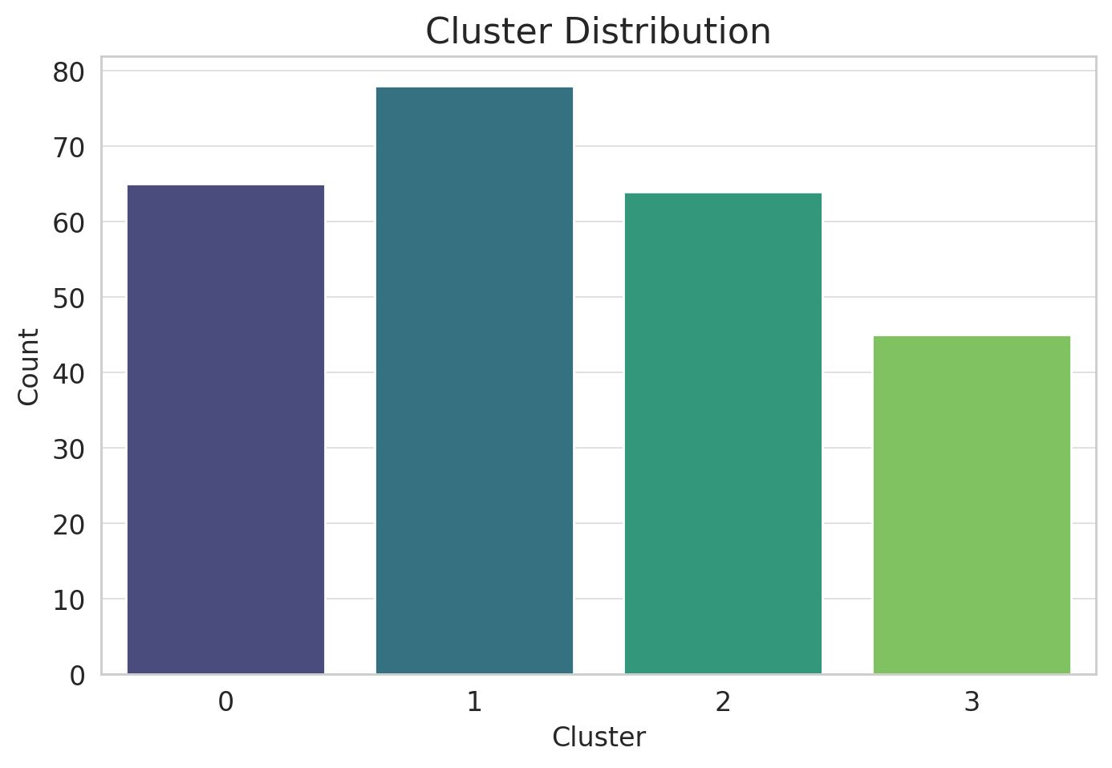
Fig. 3: Bar Chart
This chart reflects the profiles of the four clusters in terms of the proportion of the individuals in each profile performing the various gambling behaviour groups. This figure shows the proportions of young adults in each category, the highest proportion being in the occasional gambler group (Cluster 2, followed by the group that is financially affected by gambling (Cluster 4) the smallest group.
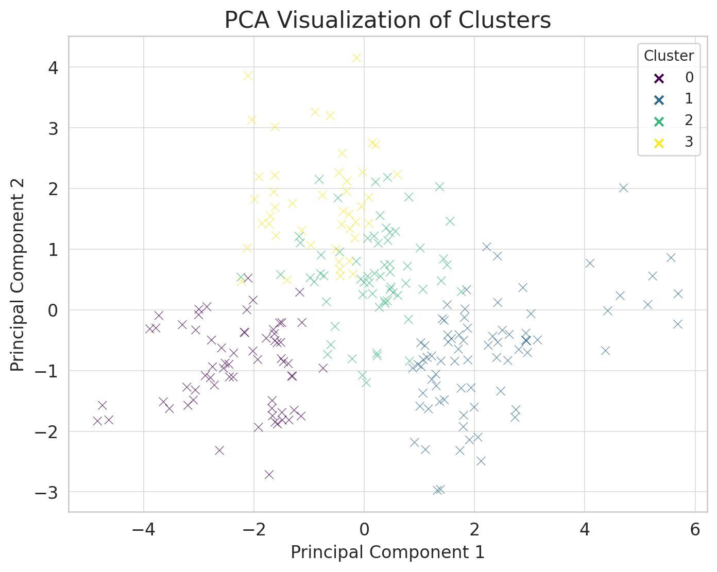
Fig 4: PCA Plot
The high dimensional data was reduced by Principal Component Analysis (PCA) to two principal components so that the clustering was clearly visualized (two dimensional). The plot shows the clusters, where each point in the plot indicates an individual, and various gamblers are colour coded as high risk, no risk, older time controlled and finically affected. How distinct the groups are in terms of their gambling behaviours is determined by the amount of separation between the clusters in the PCA plot. For instance, high risk gamblers (Cluster 1) are separated from occasional gamblers (Cluster 2) who have clear behavioural differences.
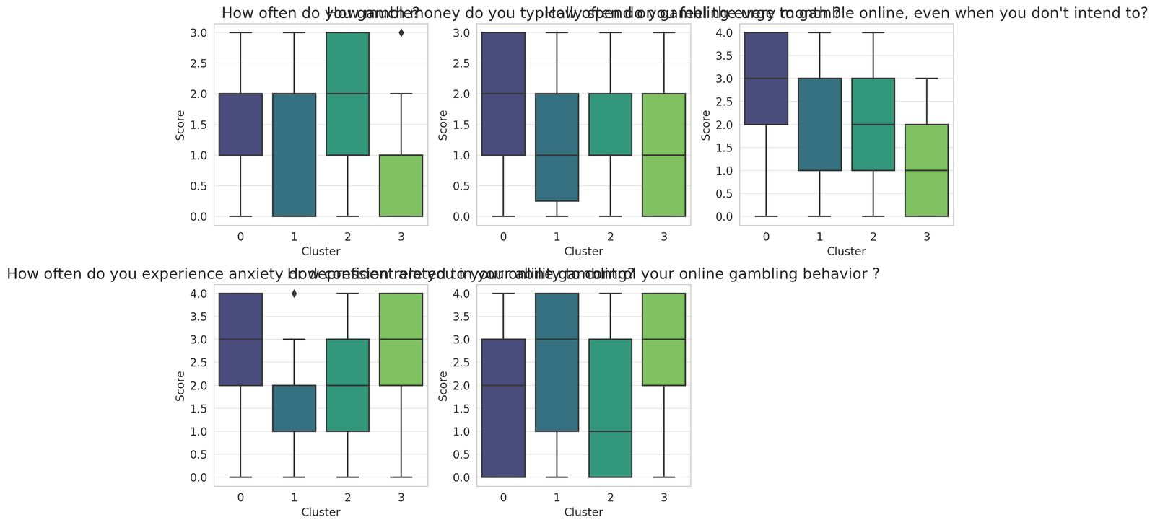
Fig 5: Box Plots
These plots compare gambling behaviours (e.g. frequency of gambling, amount spent, effects on human emotions) among the clusters to identify what the key differences are between the groups. For instance, the median frequency boxplot on gambling frequency reveals that those classified as high risk gamblers (Cluster 1) have much higher median frequency compared to occasional gamblers (Cluster 2). Like it, the boxplot for psychological impact, also shows that those financially affected gamblers (Cluster 4) are more anxious as well as more depressed than other groups.

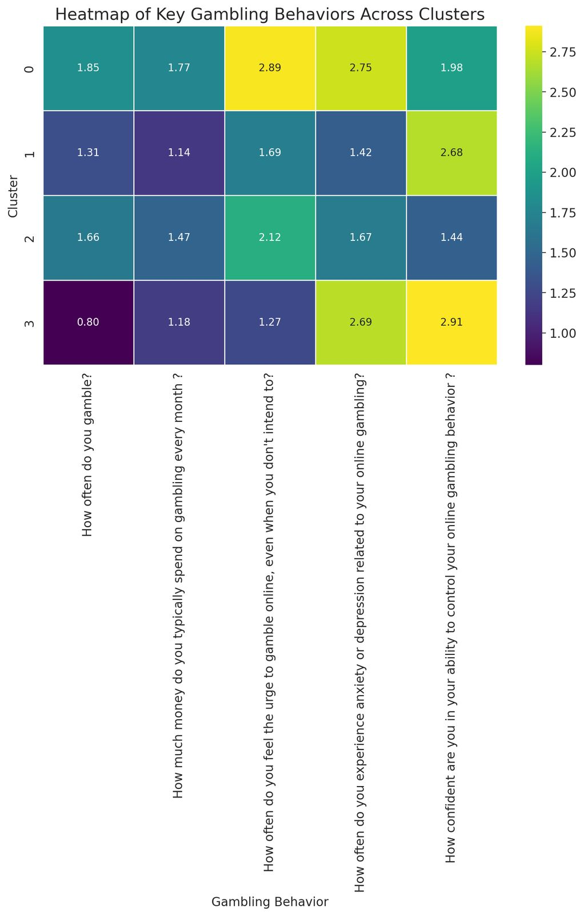
Fig 6: Heatmap
The clusters outlined revealed their differences in gambling attendance, spending and psychological impact, which are all illustrated in the heatmap. For example, Cluster 1 gamblers who are high risk would show darker shades of behaviours such as gambling frequency, spendings and psychological distress, meaning they are more involved and suffer from the adverse effects in those aspects. On the other hand, the occasional gamblers (Cluster 2) seem to have lighter shades because they do not gamble often and there are minimal negative consequences.
7. CONCLUSION
The clustering analysis revealed four distinct groups of gamblers, each with unique behavioural patterns and socio-economic impacts. These findings provide valuable insights for developing targeted interventions and policies to address the negative consequences of online gambling, particularly among high-risk and financially affected individuals. The objective of the research is met in this study through the clustering analysis that fits well in addressing the key objectives of the research by explaining the online gambling behaviours among young adults.
Firstly, the data set is analysed by segmenting it into four different groups of high-risk gamblers, occasional gamblers, older controlled gamblers and financially affected gamblers. Moreover, the degree of engagement into gambling behaviours is segmented with high-risk gamblers (Cluster 1) significant and substantial proportion of the sample.
Secondly, the clustering process is performed by including socio-economic factors (such as monthly income, financial strain, and occupational status), which enables the study to examine the factors which influence gambling behaviour. Cluster 4, who are also more prone to taking leave or selling possessions, do experience a lot of financial strain; this identifies this group of financially affected gamblers as socio-economically vulnerable.
Thirdly, the analysis evaluates the psychological impact of online gambling on the factors such as the anxiety, depression, guilt, confidence in the self-control of their gambling behaviour. Cluster 1 (high risk gamblers) is characterized with severe psychological distress including low confidence to control one’s gambling while Cluster 2 (occasional gamblers) gambling report no psychological impact at all.
Lastly, the clustering analysis does not directly assess awareness or the efficacy of regulations, but it does provide the fundamental knowledge is to focus interventions in specific places. As the study points out high risk and financially affected gamblers as the most vulnerable groups to such challenges it emphasizes the need for increasing the awareness of campaign and the support services to those suffering from socio-economic and psychological problems. Taken as a whole, the clustering analysis presents a comprehensive structure to understand how online gambling is prevalent, how its prevalence is influenced by socio-economic factors, and what are its effects on psychological aspects, while also providing the basis for further research on regulation of the distance gambling and support systems.
8. FUTURE SCOPE
For further validation, we could compare the results of K-Means with other clustering techniques, such as Hierarchical Clustering or DBSCAN, to ensure the robustness of our findings. This serves as the basis for further research towards understanding and minimizing the effect of online gambling. Another potential is on creating predictive models based on behavioral and psychological indicators to find out at what early stage people would be at risk of becoming a gambler. Future research can also study the impactiveness of usage of behavioral interventions like gamified self control tool or in app spending alerts to reduce compulsive gambling. There are several ways that a comparison between a regulated and the unregulated online gambling platforms may be able to bring out insights into how legal frameworks affect the behavior and well-being of users. In addition, it would explore the role of social media and influencer marketing in changing young adults’ attitudes to gambling, and uncovering new psychological dimensions of one of the most popular of our days. Studies with a neuroscientific and behavioral economic cross discipline can explain why in addicted behavior, cognitive biases and reward mechanism. Longitudinal studies following the long term socio economic and mental health consequences of enduring online gambling will be the last and are necessary to inform effective policy responses and support systems. These future studies can make a significant contribution in completing a more complete, evidence driven response to the growing incidence of youth participating online.

9. REFERENCES
Antonio, J. C., Ong, A. K. S., Diaz, J. F. T., Cahigas, M. M. L., & Gumasing, Ma. J. J. (2025). The perceived risk and return, curiosity, and control analysis of online gambling intention among Gen Z and Millennials using extended UTAUT3. Entertainment Computing, 52, 100918. https://doi.org/10.1016/j.entcom.2024.100918
Bush-Evans, R., Arden-Close, E., Thomas, S., McAlaney, J., Wang, R., Bolat, E., Hodge, S., Hamson-Ford, A., & Phalp, K. (2024). Promoting safer gambling through social norms and goal setting: A qualitative process analysis of participants’ experiences in the EROGamb 2.0 feasibility trial. Internet Interventions, 38, 100790. https://doi.org/10.1016/j.invent.2024.100790
Dowling, N. A., Hawker, C. O., Merkouris, S. S., Rodda, S. N., & Hodgins, D. C. (2025). Addressing Gambling Harm to affected others: A scoping review (part II: Coping, assessment and treatment). Clinical Psychology Review, 116, 102543. https://doi.org/10.1016/j.cpr.2025.102543
Fahrudin, A., Satispi, E., Subardhini, M., Rinda Andayani, R. H., Jayaputra, A., Yuniarti, L., Wijayanti, F., & Suryani, S. (2024). Online gambling addiction: Problems and solutions for policymakers and stakeholders in Indonesia. Journal of Infrastructure, Policy and Development, 8(11), 9077. https://doi.org/10.24294/jipd.v8i11.9077
Indra, I. M., Japari, A., Novika, F., Septivani, C. N., Rosmayanti, M., & Chalista, B. (n.d.). THE PHENOMENON OF ONLINE GAMBLING UNDER THE GUISE OF ONLINE GAMES AMONG THE YOUNGER GENERATION.
Kartawinata, B. R., Syarifuddin, S., Kuswanto, A., & Wardhana, A. (2025). Financial Literacy Series: Protect Your Family from Online Gambling. Journal of Digital Community Services, 2(1), 16–22. https://doi.org/10.69693/dcs.v2i1.23
Koomson, I., Churchill, S. A., & Munyanyi, M. E. (2022). Gambling and Financial Stress. Social Indicators Research, 163(1), 473–503. https://doi.org/10.1007/s11205-022-02898-6
Lakew, N., Jonsson, J., & Lindner, P. (2024). Towards an Active Role of Financial Institutions in Preventing Problem Gambling: A Proposed Conceptual Framework and Taxonomy of Financial Wellbeing Indicators. Journal of Gambling Studies, 40(4), 1857–1886. https://doi.org/10.1007/s10899-024-10312-8
Lombardi, G., Molinaro, S., Cotichini, R., Cerrai, S., Scalese, M., & Benedetti, E. (2024). The cards they’re dealt: Types of gambling activity, online gambling, and risk of problem gambling in European adolescents. Social Science & Medicine, 363, 117482. https://doi.org/10.1016/j.socscimed.2024.117482
Nur, A. I., Fatih, S. A., & Hermanto, B. (n.d.). Eradicating Online Gambling in Indonesia: Reinforcing the Role of Digital Sovereignty and Content Moderation in Cyberspace.
Potenza, M. N., Mestre-Bach, G., Demetrovics, Z., Derevensky, J., Fernandez-Aranda, F., Gainsbury, S. M., Jiménez-Murcia, S., & Kraus, S. W. (2025). Online Gambling in Youth. In D. A. Christakis & L. Hale (Eds.), Handbook of Children and Screens (pp. 597–603). Springer Nature Switzerland. https://doi.org/10.1007/978-3-031-69362-5_81
Vijayakumar, L., & Vijayakumar, V. (2023). Online gambling and suicide: Gambling with lives. Indian Journal of Psychiatry, 65(1), 3–4. https://doi.org/10.4103/indianjpsychiatry.indianjpsychiatry_817_22
Villalba-García, C., Griffiths, M. D., Demetrovics, Z., & Czakó, A. (2025). The relationship between loot box buying, gambling, internet gaming, and mental health: Investigating the moderating effect of impulsivity, depression, anxiety, and stress. Computers in Human Behavior, 166, 108579. https://doi.org/10.1016/j.chb.2025.108579

